Assignment 10.4
Ai Assisted Coding
Htno:2303A51310
Btno: 05
Task 1:
AI-Assisted Syntax and Code Quality Review
Scenario
You join a development team and are asked to review a junior developer’s Python script that fails to run correctly due to basic coding mistakes. Before deployment, the code must be corrected and standardized.
Task Description
You are given a Python script containing:
- Syntax errors
- Indentation issues
- Incorrect variable names
- Faulty function calls
Use an AI tool (GitHub Copilot / Cursor AI) to:
- Identify all syntactic and structural errors
- Correct them systematically
- Generate an explanation of each fix made
Expected Outcome
- Fully corrected and executable Python code
- AI-generated explanation describing: o Syntax fixes o Naming corrections
o Structural improvements • Clean, readable version of the script
Code:
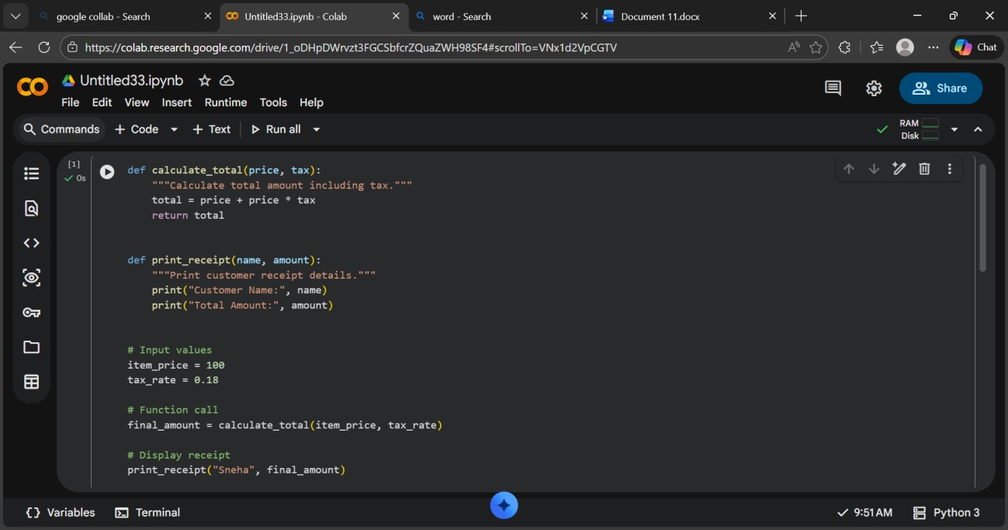
Output:
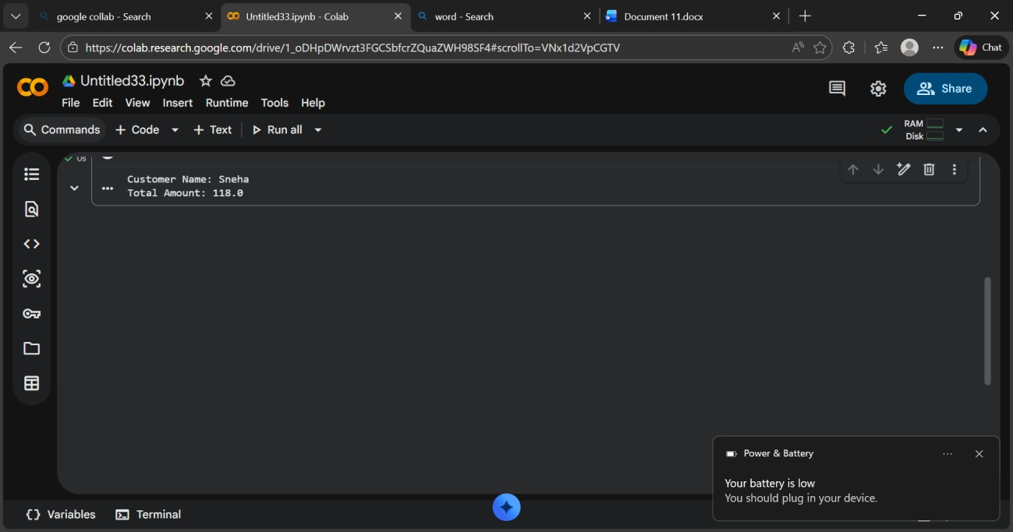
Explanation:
-->AI fixed syntax mistakes and indentation errors in the script.
-->It corrected wrong function calls and mismatched variable names.
-->Naming was standardized using proper Python conventions.
-->The code structure was cleaned and organized properly.
-->The final program runs correctly without errors.
Task 2:
Performance-Oriented Code Review
Scenario
A data processing function works correctly but is inefficient and slows down the system when large datasets are used.
Task Description
You are provided with a function that identifies duplicate values in a list using inefficient nested loops.
Using AI-assisted code review:
- Analyze the logic for performance bottlenecks
- Refactor the code for better time complexity
- Preserve the correctness of the output Ask the AI to explain:
- Why the original approach was inefficient
- How the optimized version improves performance
Expected Outcome
- Optimized duplicate-detection logic (e.g., using sets or hash- based structures)
- Improved time complexity
- AI explanation of performance improvement
- Clean, readable implementation
- Code:
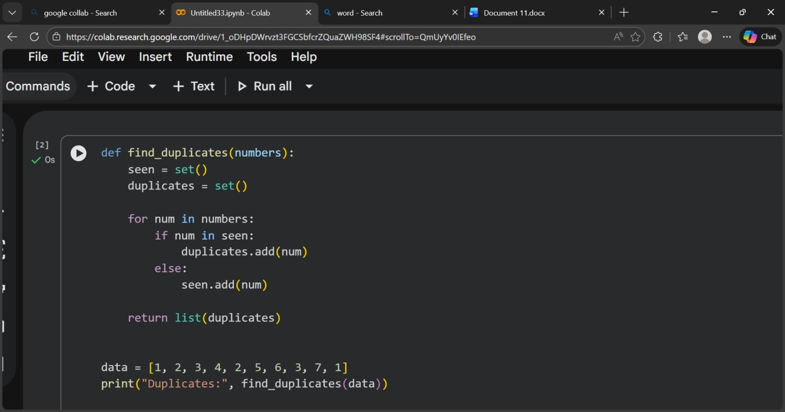
Output:
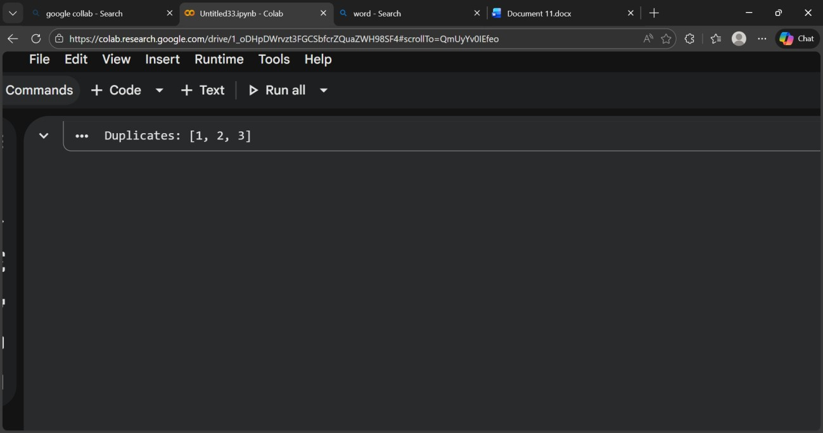
Explanation:
-->The original code used nested loops, comparing each element with every other element.
-->This caused O(n²) time complexity, making it slow for large lists.
-->The optimized version uses a set for quick lookup of seen elements.
-->Set operations work in O(1) time, allowing duplicates to be found in one pass.
-->This reduces overall complexity to O(n), improving performance while keeping correct results.
Task 3:
Readability and Maintainability Refactoring
Scenario
A working script exists in a project, but it is difficult to understand due to poor naming, formatting, and structure. The team wants it rewritten for long-term maintainability.
Task Description
You are given a poorly structured Python function with:
- Cryptic function names
- Poor indentation
- Unclear variable naming
- No documentation
Use AI-assisted review to:
- Refactor the code for clarity
- Apply PEP 8 formatting standards
- Improve naming conventions
- Add meaningful documentation
Expected Outcome
- Clean, well-structured code
- Descriptive function and variable names
- Proper indentation and formatting
- Docstrings explaining the function purpose
- AI explanation of readability improvements Code:
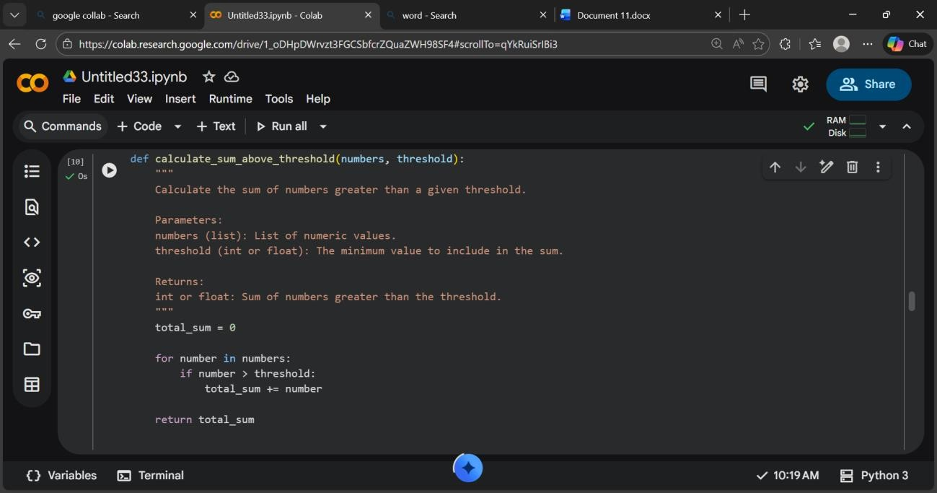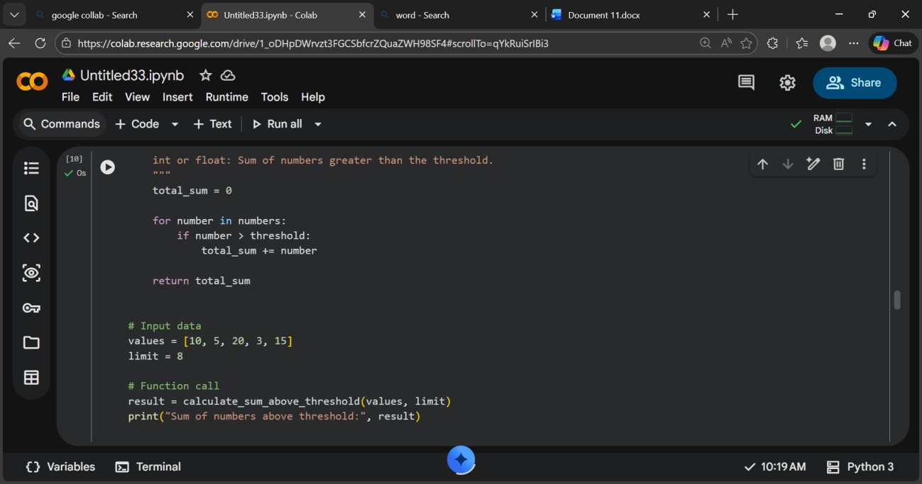
Output:
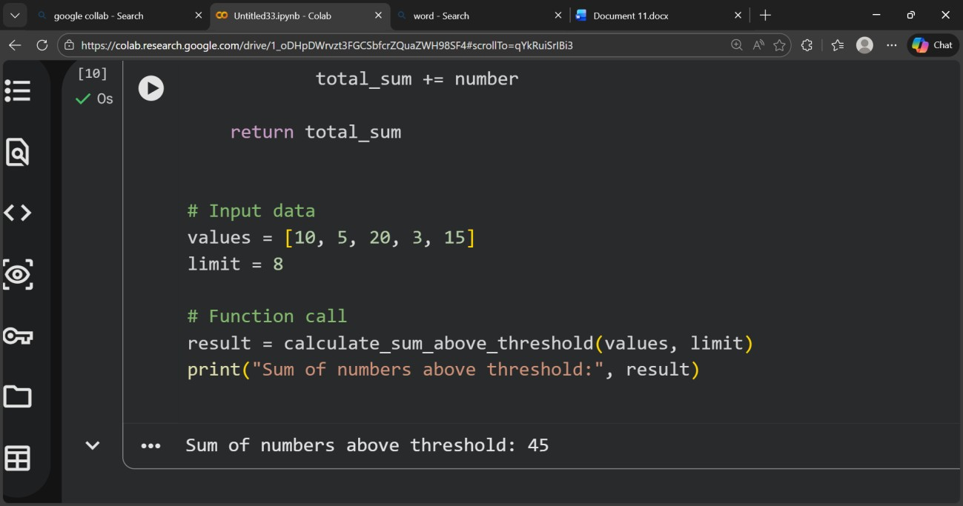
Explanation:
-->The original code was hard to understand due to unclear function and variable names, poor formatting, and no documentation.
--> The refactored version improves readability by using a descriptive function name and meaningful variable names.
-->Proper indentation and spacing were applied following PEP 8 standards. A docstring was added to explain the function’s purpose, parameters, and return value.
--> These changes make the code easier to read, maintain, and modify in the future.
Task 4:
Secure Coding and Reliability Review
Scenario
A backend function retrieves user data from a database but has security vulnerabilities and poor error handling, making it unsafe for production deployment.
Task Description
You are given a Python script that:
- Uses unsafe SQL query construction
- Has no input validation • Lacks exception handling Use AI tools to:
- Identify security vulnerabilities
- Refactor the code using safe coding practices
- Add proper exception handling
- Improve robustness and reliability
Expected Outcome
- Secure SQL queries using parameterized statements
- Input validation logic
- Try-except blocks for runtime safety
- AI-generated explanation of security improvements
- Production-ready code structure Code:

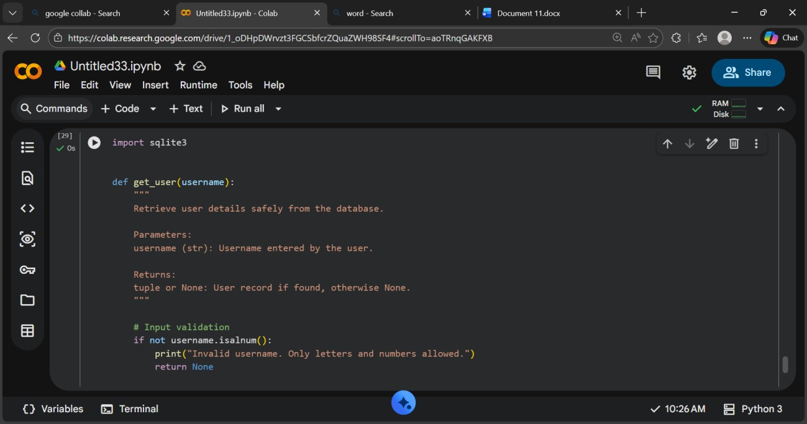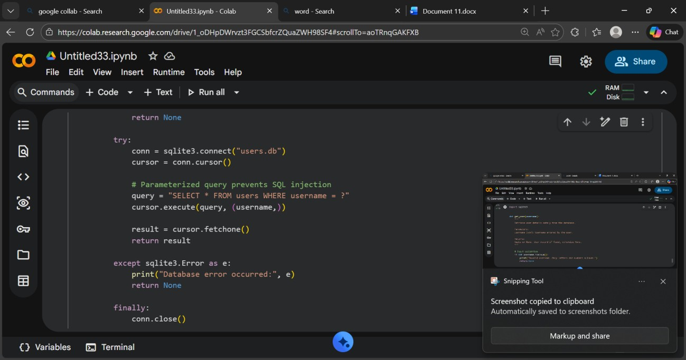

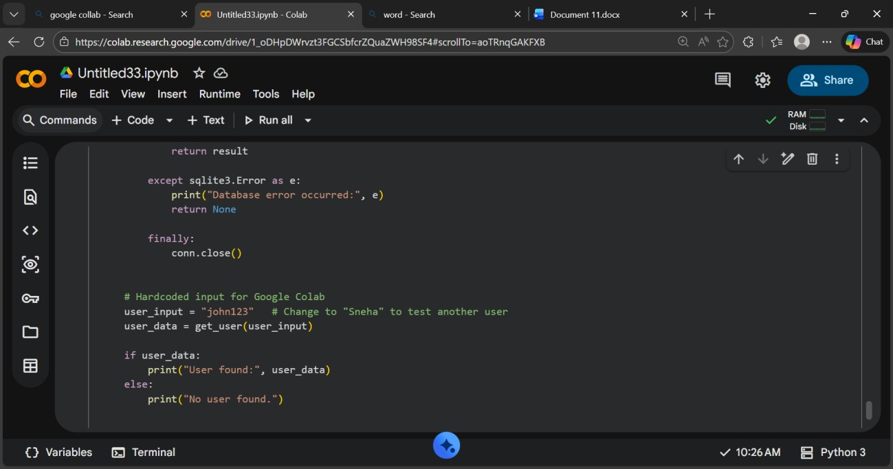
Output:
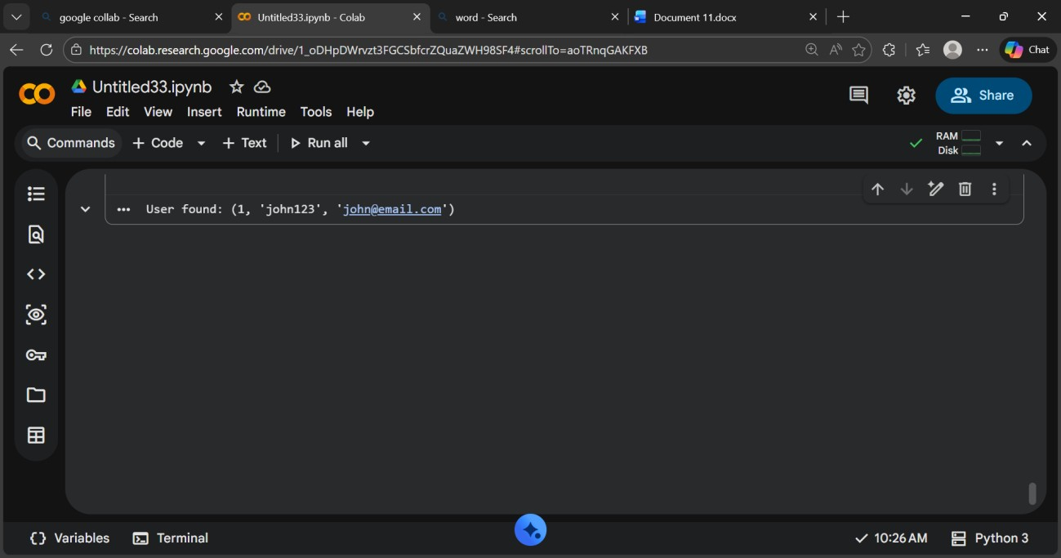
Explanation:
-->The original code was insecure because it built SQL queries using string concatenation, which could lead to SQL injection attacks.
-->The refactored version uses parameterized queries (?) to safely pass user input to the database.
-->Input validation was added to ensure only alphanumeric usernames are accepted, reducing the risk of malicious input.
-->Try–except blocks were introduced to handle database errors without crashing the program.
--> A finally block ensures the database connection is always closed, improving reliability and making the code safe for production use.
Task 5:
AI-Based Automated Code Review Report
Scenario
Your team uses AI tools to perform automated preliminary code reviews before human review, to improve code quality and consistency across projects.
Task Description
You are provided with a poorly written Python script.
Using AI-assisted review:
• Generate a structured code review report that evaluates:
o Code readability o Naming conventions o Formatting and style consistency o Error handling o Documentation quality o Maintainability
The task is not just to fix the code, but to analyze and report on quality
issues.
Expected Outcome
• AI-generated review report including:
o Identified quality issues o Risk areas o Code smell detection o Improvement suggestions • Optional improved version of the code
Code:
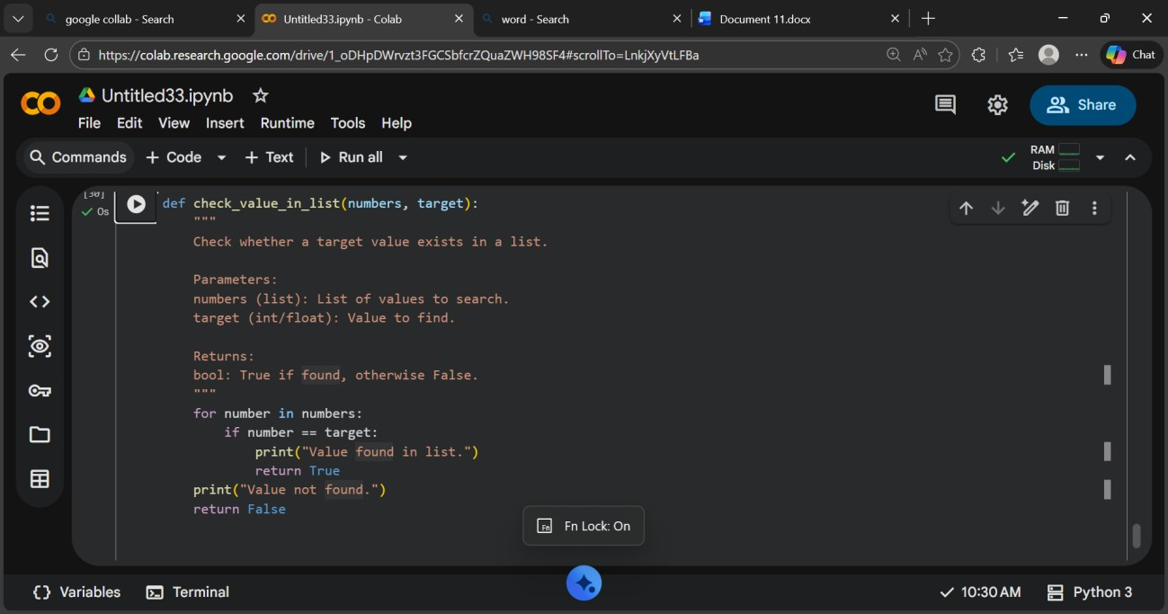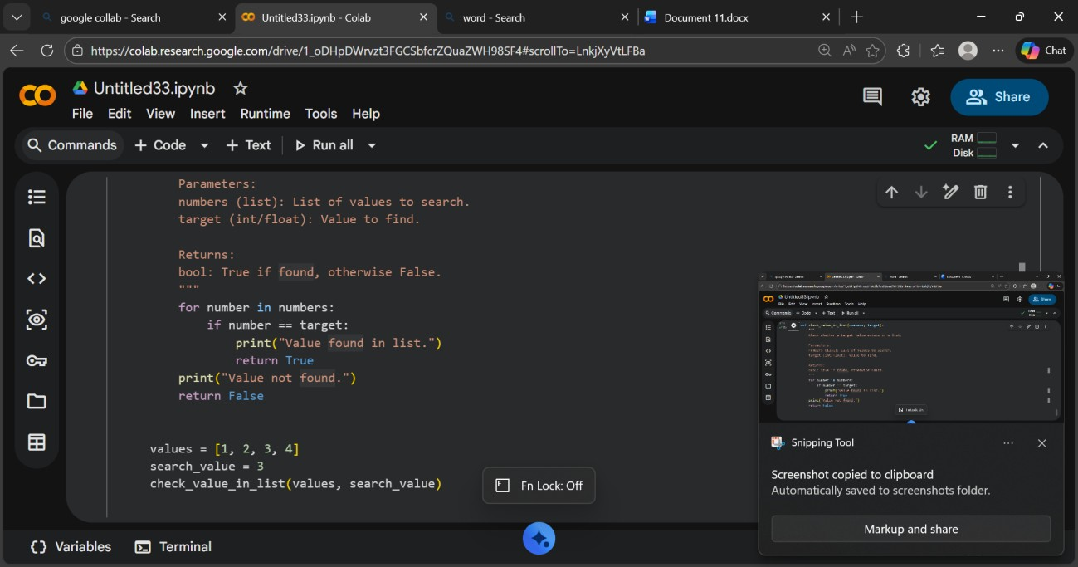
Output:
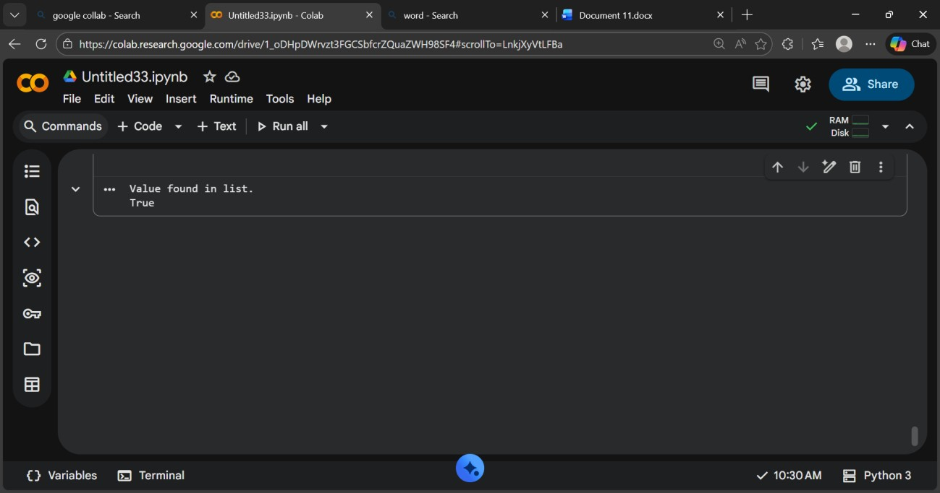
Explanation:
-->In this task, AI was used as a code reviewer to analyze code quality instead of just fixing errors.
-->The AI identified issues related to poor readability, unclear naming, bad formatting, missing documentation, and lack of error handling.
-->It also detected code smells such as unused variables and unnecessary statements. Based on this analysis, improvement suggestions were provided to make the code more maintainable and professional.
-->This demonstrates how AI helps teams perform faster and more consistent preliminary code reviews before human evaluation.

